FACULTY EVALUATION
Programme Name: Sisters’ Blended Value Program (Sbvp)Social Entrepreneurship Development Program (SEDP) Advance Module 3 Zambia (26th January 2026 - 30th January 2026)
Session: IT and Technology
Faculty Name: Isaac Kipkosgei Kigen
No. of Respondents: 11
No. of Participants: 11
Evaluation Parameter | (%) Individual Score | (%) Programme Average
Punctuality (Commencement and Completion of Sessions) | 100 | 95
How well do you understand the core concepts presented? | 90 | 91
Rate your confidence in applying the new skills learnt | 90 | 92
Degree of Faculty preparedness for the sessions | 100 | 95
Content and methodology of the program | 100 | 96
Quality of class and group discussions | 100 | 95
The information presented in the course is relevant to my work (ministry) | 100 | 92
Average scores | 97 | 94

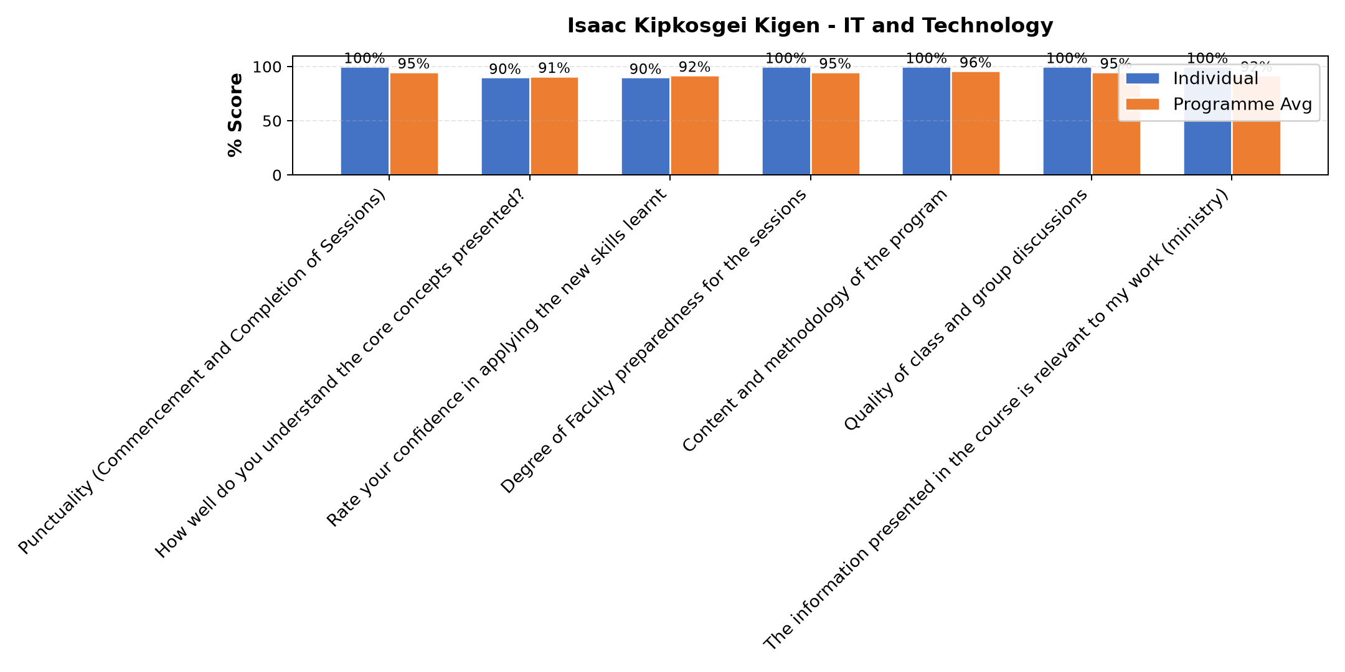

Comments & Feedback
- • Even though today the network did not allow much tomorrow it will be better
- • very come and patience.
- • More time for practice
- • It was very effective to my project
- • Thanks
- • i want to learn more about iT
- • This was an excellent practical and informative Topic
- • Very good and well done
- • The lesson was interesting
- • It a very educative and helping topic
- • Well kectured
SUBMITTED THROUGH:
SBS Evaluation Automation System

